Technical Project Team

Umbrella Roaming Client DNS Issues Fix
Standard Operating Procedure

PREPARED BY
Kelvin Aruin – Senior Technical Project Engineer

TABLE OF CONTENTS
Fix Azure Hostname Resolution due to Umbrella 3

Fix Azure VPN Client Issues due to Umbrella
If a user machine is unable to resolve the new DNS server in your environment, it is more than likely due to the Cisco Umbrella RC agent caching the old DNS IP settings. You can confirm that this is the issue by running the command ‘ipconfig /all’ in the command prompt to check the DNS IP. If the IP is 127.0.0.1, then this is indeed the reason why this machine is not able to resolve new DNS paths, etc.
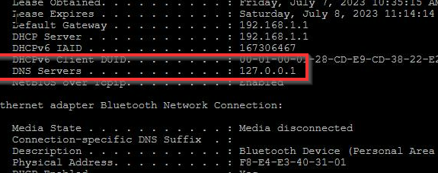
There is a workaround that will fix this problem. This fix also resolves the Azure VPN resolution problem, so if you are moving users to Azure VPN later, this will take care of that issue now and you will not have to do this when the new VPN client is deployed.
Steps to Resolve:
- Check to see if the Umbrella Roaming client is installed.
  - You can see this by checking services and seeing if a service called Umbrella_RC exists.
- If installed, uninstall the Umbrella Roaming Client via the control panel or settings.
  - NOTE: There is an AMP for uninstalling Umbrella, if you have a lot of machines and not working on just one. The AMP for uninstalling is Impact - Uninstall Umbrella AMP. This can be run via a scheduled task in INC to address more than one machine.
  - However, manually uninstalling the Cisco Umbrella Roaming client via Control Panel seems to work faster.
- Confirm the client is uninstalled by checking services for Umbrella_RC service. It should now be gone.
- Delete the directory named OpenDNS located at “C:\ProgramData\OpenDNS” on the client machine.
- Make sure the OpenDNS folder is no longer visible in the “C:\ProgramData” folder.
- Open network adapter settings and check the TCP/IP configuration.
  - Set the DNS to the correct IP if needed. Do not leave the 127.0.0.1 entry and update to the domain controller or public DNS.
- Validate you are now able to access DNS entries, such as the file server mapped drives with the Umbrella client removed and the correct DNS settings set on the client machine.
- If everything works as expected, continue to the next step. If not, you may need to perform additional troubleshooting.
- Once confirmed, create an Automation Task in INC4 and use the Impact - Deploy Cisco Secure Client - Umbrella AMP.
- The task will require the following settings:
  - 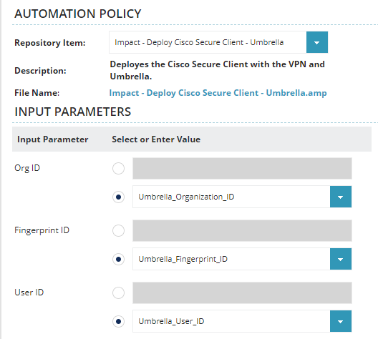

- Allow time for the installation to be completed.
- Check services for the CSC_UmbrellaAgent service and make sure it is running.
- You may need to restart the user workstation.
- Now try browsing the mapped drives or server shares that did not resolve or allow access before.
- If the client machine is located outside of the office, connect to the VPN and re-try step number 9.

